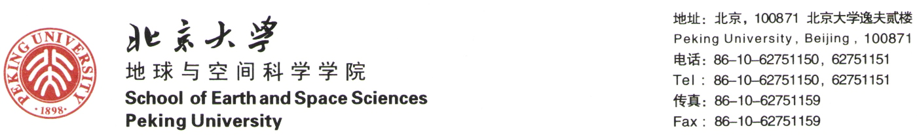

**关于召开第五届“国际青年学者地质学论坛（网络论坛2021）”的通知**

“国际青年学者地质学论坛”旨在面向海内外邀请地质学领域的优秀青年学者，围绕地球科学前沿和热点研究展开学术讨论，增强北京大学地质科学国际交流与合作，建立优秀国际地质学青年人才的学术交流与合作平台。

**一、论坛形式**

**网络论坛**。

**二、论坛时间**

**2021年5月28日-5月29日（腾讯会议平台）**。

**三、论坛学科**

网络论坛主要涉及学科：行星地质学、构造地质学、地球化学、古生物与地层学、地震地质学、第四纪环境、活动构造与地貌学、实验岩石学、岩石-矿物-矿床学等。

**四、报名条件**

1、年龄在40岁以下；

2、在本领域已经取得学术积累和研究成果，具有较强的学术影响力和发展潜力。

**五、申请流程**

1、请在北京大学地球与空间科学学院网页下载并填写《“国际青年学者地质学论坛（网络论坛2021）”报名表》（也见本通知后附有报名表格）。

2、报名表发至邮箱geozhangbo@pku.edu.cn，**报名截止日期2021年5月18日**。

**六、会务组及联系方式**

会议组长：张立飞（010-62751146）；

会议副组长：张进江（010-62754162）；江大勇 （010-62754154）

会务秘书：张波 （+86-01-62758325，[geozhangbo@pku.edu.cn](mailto:geozhangbo@pku.edu.cn) ）

张贵宾 （010-62755567，[gbzhang@pku.edu.cn](mailto:gbzhang@pku.edu.cn) ）

李艳（[liyan-pku@163.com](mailto:liyan-pku@163.com) ）

沈冰 （[bingshen@pku.edu.cn](mailto:bingshen@pku.edu.cn) ）

唐铭 （[mingtang@pku.edu.cn](mailto:mingtang@pku.edu.cn) ）

程丰 （[cfcf.chengfeng@gmail.com](mailto:cfcf.chengfeng@gmail.com) ）

会务组： 常燎，陈咪咪，董琳，沈冰，沈佳恒，李艳，李姝宁，李文博，李秋根，刘平平，刘曦，刘琼，吕增，许成，何涛，薛进庄，张波，张贵宾，张南，张元元，张丽娟

地址：北京大学 地球与空间科学学院 逸夫二楼3319，北京.海淀

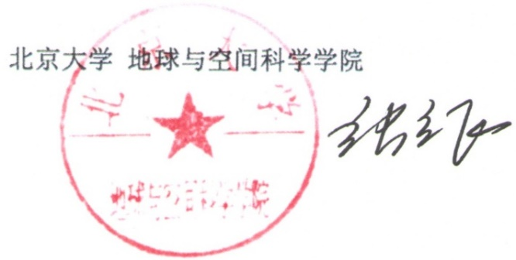

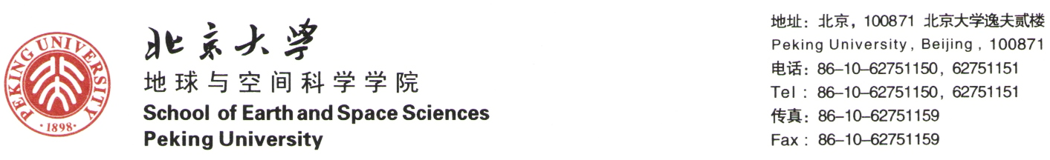

**Announcement of The Fifth International Young Scholars Geo-Symposium**

**(The Webinar.2021)**

Welcome to Peking University (PKU) "International Young Scholars Geo-Symposium"! Geo-Symposium provides a unique academic platform for communication and coordination among pre-career scientists at home and abroad in earth science. At Geo-Symposium, outstanding scholars may share their cutting-edge research and creative energies with enthusiastic students and professors on PKU campus, which potentially opens up a window to PKU faculty position applications for competitive scientists.

**1. Geo-Symposium Webinar**

May 28 to 29, 2021

Network platform: Tencent Meeting

**2. Geo-Symposium Disciplines**

Planetary Geology, Tectonics, Structural Geology, Geochemistry, Paleobiology and Stratigraphy, Seismological Geology, Quaternary environmental changes, Active Tectonics and Geomorphology, Experimental petrology, and Petrology-Mineralogy-Economic geology, etc. Yes! We welcome new cross-disciplinary science.

**3. Qualification requirement**

A qualified applicant should fulfill the following:

1. Age under 40 years old.
2. Received a doctoral degree from prestigious university or institute, or holding a doctoral degree from a domestic university or institute and have a minimum of one or two years of overseas research experience.
3. Equipped with outstanding academic achievements.

**4. Application procedure**

1. Download and complete the application form (Application Form of The Fifth International Young Scholars Geo-Symposium). (Download from website: https://sess.pku.edu.cn/index.htm).
2. Send the application form and a Curriculum Vitae to geozhangbo@pku.edu.cn by May 18, 2021.
3. Qualified applicants will receive a formal invitation letter before May 21, 2021.

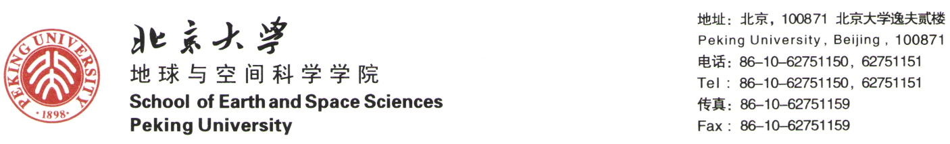

**5. Contact us**

Chairman of organizing committee:

Lifei Zhang Professor, Director of School of Earth and Space Sciences

Jinjiang Zhang Professor, Vice Director of School of Earth and Space Sciences

Organizing committee:

Bo Zhang, Bin Shen, Cheng Xu, Guibin Zhang, Jinzhuang Xue, Tao He, Liao Chang, Lin Dong, Shuning Li, Wenbo Li, Jiaheng Shen, Qiugeng Li, Pingping Liu, Xi Liu, Qiong Liu, Zeng Lv, Nan Zhang, Yuanyuan Zhang, Ming Tang, Feng Cheng

Conference Secretary:

Bo Zhang, Associate Professor

Bing Shen, Professor

Guibing Zhang, Associate Professor

Yan Li, Associate Professor

Ming Tang, Assistant Professor

Feng Cheng, Assistant professor.

Conference telephone and e-mail:

Tel: +86-01-62758325 (Dr. Bo Zhang)

Email: geozhangbo@pku.edu.cn

Website: <https://sess.pku.edu.cn>

Address: Room-3319# Yifu Building-2, Peking University, Haidian, Beijing, 100871, China



Lifei Zhang Professor, Dean

School of Earth and Space Sciences, Peking University

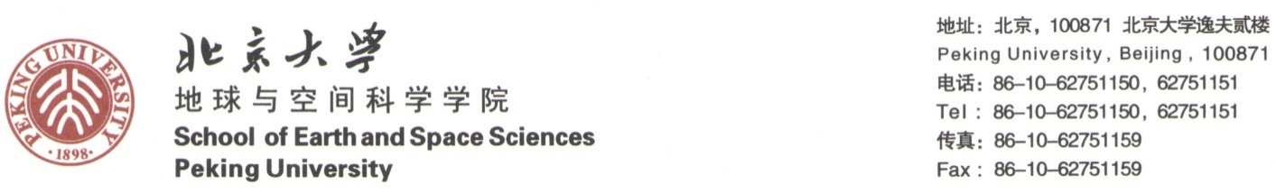

**“国际青年学者地质学论坛 (网络论坛.2021)”报名表**

**Application Form of The Fifth International Young Scholars Geo-Symposium**

**(The Webinar. May 28 to 29, 2021. Peking University)**

**Please complete the application form and submit it to [geozhangbo@pku.edu.cn](mailto:geozhangbo@pku.edu.cn) before May 18, 2021**

|  |  |  |  |  |  |
| --- | --- | --- | --- | --- | --- |
| 姓名 Name |  | | 国籍Nationality | |  |
| 出生年月Date of Birth |  | | 出生地Birthplace | |  |
| 参会报告题目  Topic for the Geo-Symposium |  | | | | |
| 目前就职学校/研究机构  Current University/Institute |  | | | | |
| 目前专业与研究领域  Current research/interest |  | 现职位属性  Current position | |  | |
| 获博士学位时间及学校/院系/专业  Time, and University when you got your doctoral degree and your entitled Major | |  | | | |
| 获硕士学位时间及学校/院系/专业  Time, and University when you got your master degree and your entitled Major | |  | | | |
| 获学士学位时间及学校/院系/专业  Time, and University when you got your bachelor degree and your entitled Major | |  | | | |
| 学术兴趣与科研成就  Introduction of your research interest and academic achievements |  | | | | |
| 代表性学术论文/专著/出席会议：  Publications： | | | | | |