**Life and death of chemical reaction fronts – experimental study on the kinetics of mineral replacement**

In the geosphere, fluid-mediated mineral reactions are of pivotal importance in governing the redistribution of elements and isotopes. Incomplete elemental redistribution is preserved in the rock record in the form of geochemical reaction fronts, the boundaries between reacted and unreacted material. Such fronts control geochemical exchange between the hydrosphere and the geosphere, the formation of mineral deposits, and migration of aqueous fluids and melt in the lithosphere. Associated mineralogical changes can dramatically change the physicochemical properties of Earth materials affecting their flow properties (rheology), strength, porosity and permeability. Recent experimental work has shown that reaction rates of metasomatic fronts are likely controlled by the transport of elements contradicting previous assumptions of dissolution/precipitation-controlled reaction rates. Understanding the dynamics of progression and stagnation of reactive fronts is therefore one of the most important challenges in geoscience.

In this talk, I will present our latest results of mineral replacement experiments under diagenetic conditions, focussing on dolomitisation, the secondary replacement of calcite (CaCO3) by dolomite (CaMg[CO3]2) as case study. This reaction is readily accessible to low/moderate temperature experimentation, and can therefore be used to infer process in many other mineralogical settings. In the talk I will present convincing evidence that the reaction front dynamics is controlled by the evolution of fluid transport to and from reaction sites. This transport depends on a balance between transport-enabling reaction steps such as dissolution and pore formation and transport-inhibiting reaction steps such as recrystallization and mineral precipitation. Finally, I will link experimental and theoretical studies of dolomitisation to provide a new qualitative and quantitative framework for predicting reaction front behaviour in general.

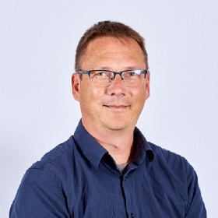Dr Thomas Mueller is lecturer in metamorphic petrology and hydrothermal systems at the University of Leeds. His research focuses on fluid-rock interaction and in particular rates, mechanisms and timescales of kinetically controlled mineral and texture formation using a combination of analytical methods, experimental techniques and field work together with numerical modelling. Current research projects include Early Earth metamorphism (Isua greenstone belt), mineral replacement, reactive transport modelling for geothermal reservoirs and nuclear waste deposits. Thomas has recently been awarded the Max Hey Medal 2019 by the Mineralogical Society of Great Britain for excellence in petrological sciences.